

FACULTY OF ENGINEERING

SCHOOL OF COMPUTING

SEMESTER 1/20192020

**SCSP3723 - SYSTEM DEVELOPMENT TECHNOLOGY**

**INDIVIDUAL ASSIGNMENT REPORT**

**LECTURER:** DR HAZA NUZLY BIN ABDULL HAMED

**SECTION:** 01

**Name:** MUHAMMAD HILMAN BIN HASHIM (A18CS0148)

**Code/Development and Explanation**

1. Revamp UI and UX

- The template of the landing page, admin’s dashboard and user’s landing page has been changed. Bootstrap template was used in both landing and dashboards pages.

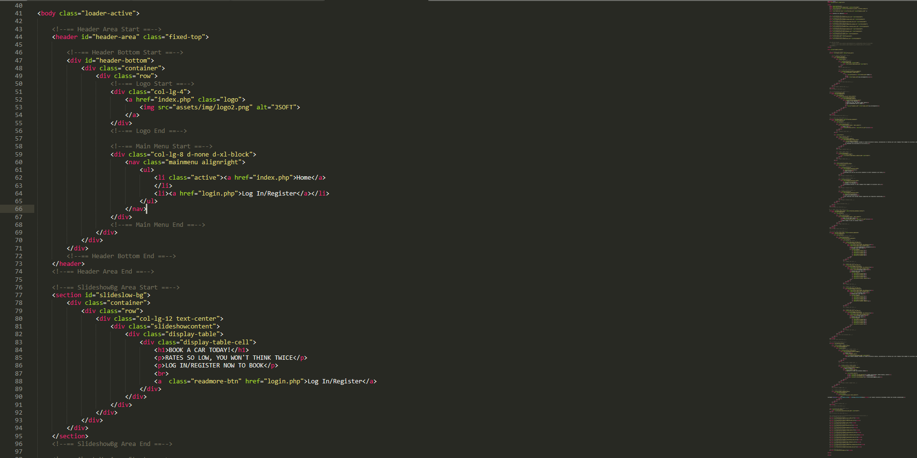

Landing Page’s Coding

Landing Page

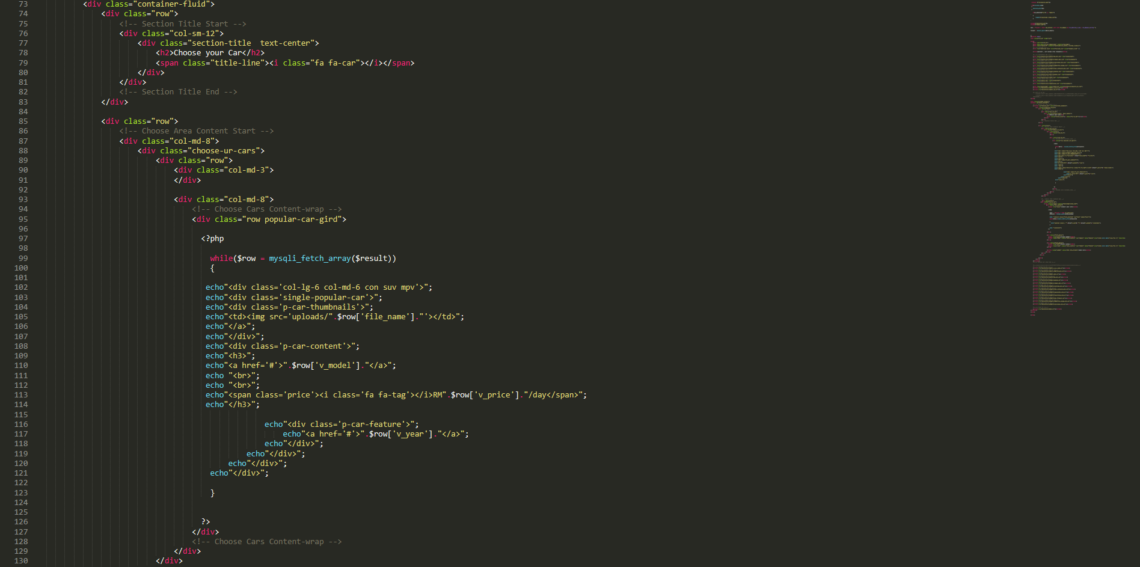

User’s Landing Page Coding

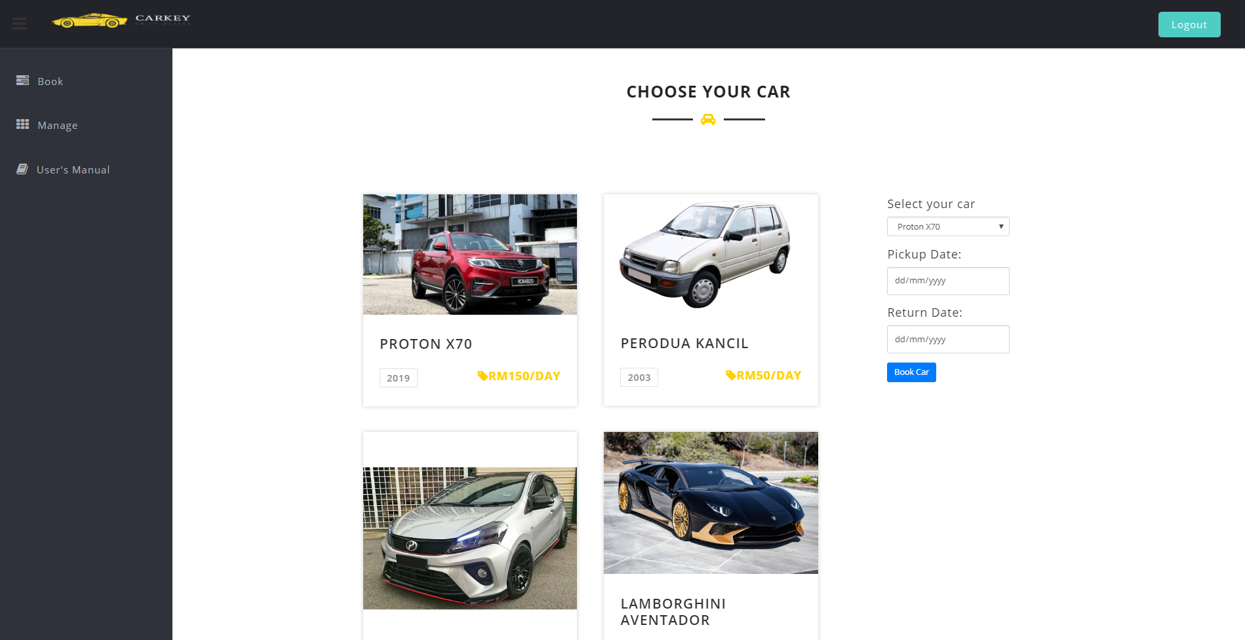

User’s Landing Page

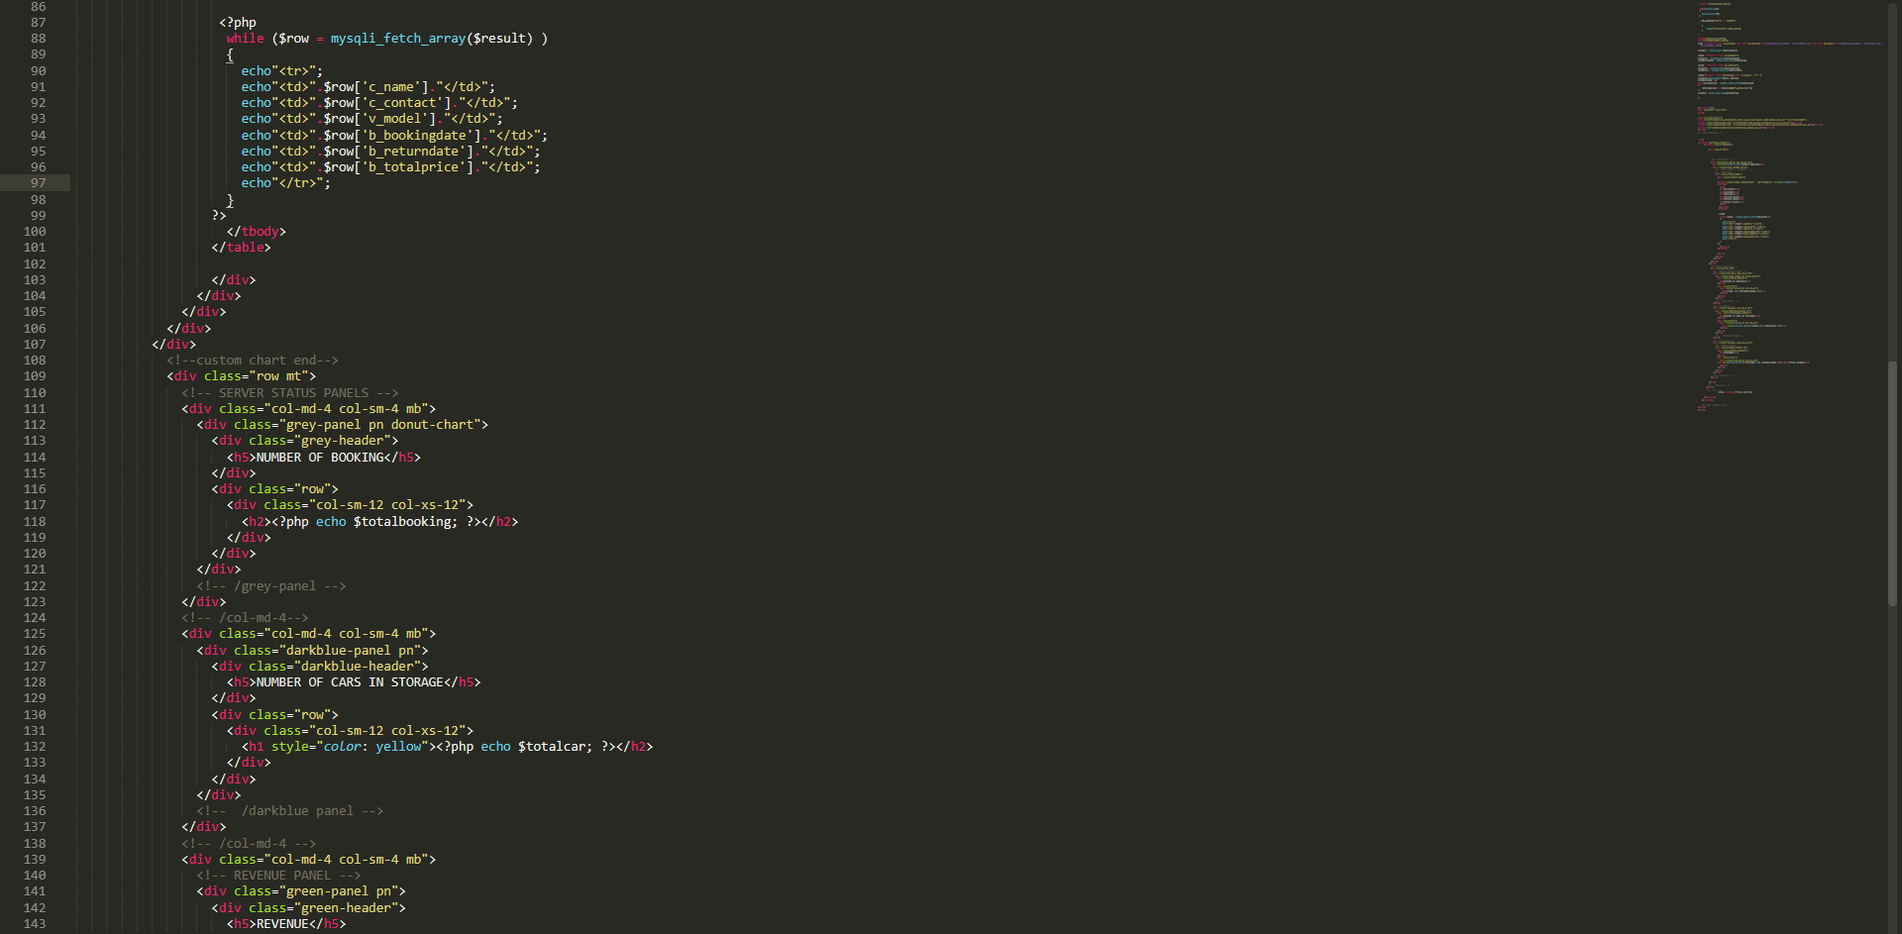

Admin’s Dashboard Coding

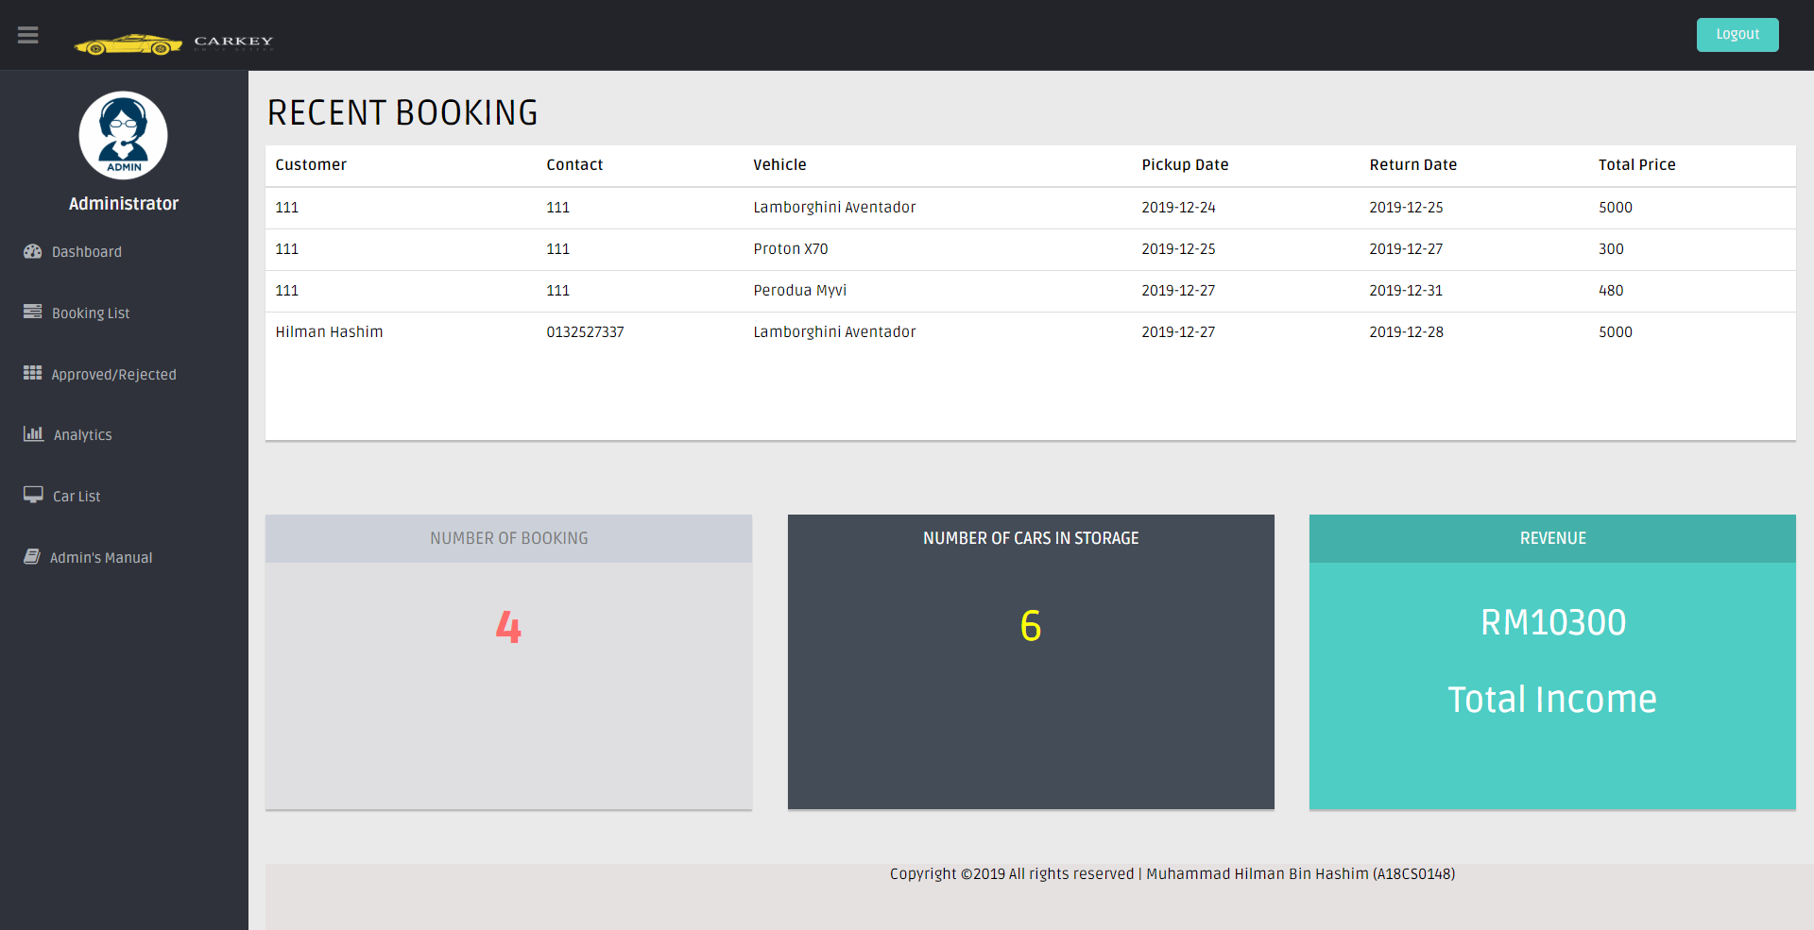

Admin’s Dashboard

- Most features on all pages has been drastically improved compared to previous version.

- All the information that is shown are extracted from database.

2. Hash Password

- Password that has been inserted during registration using “password_hash” password where the password that were inserted is sent as hash into database.

- During retrieval of password in login’s process, “password_verify” function was used to decrypt the hashed password from the database.

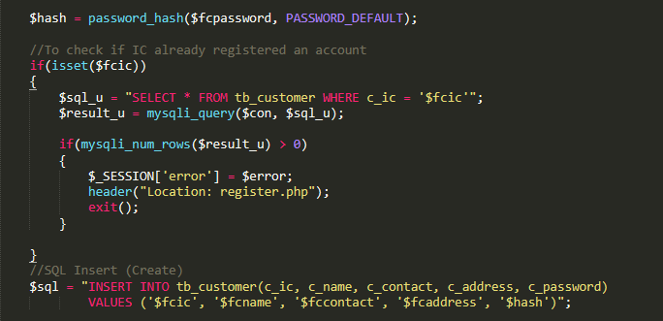

Hashing Password Coding

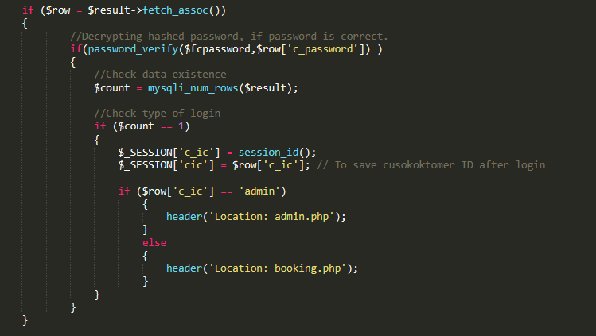

Decrypting Hashed Password Coding

3. SQL Injection

- SQL injection was prevented by using “Prepared Statement” in order to stop any hackers or irresponsible user from messing with the database and corrupting it.

- mysqli_real_escape_string() function was also used in every process that is in this project.

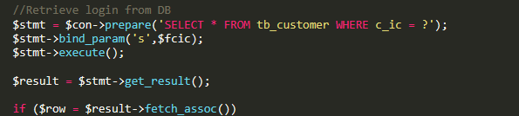

Prepared Statement Coding

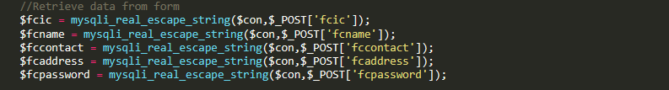

mysqli_real_escape_string() Function Coding

4. Retrieve Data from Database.

- All the data and information shown on this project were extracted from database.



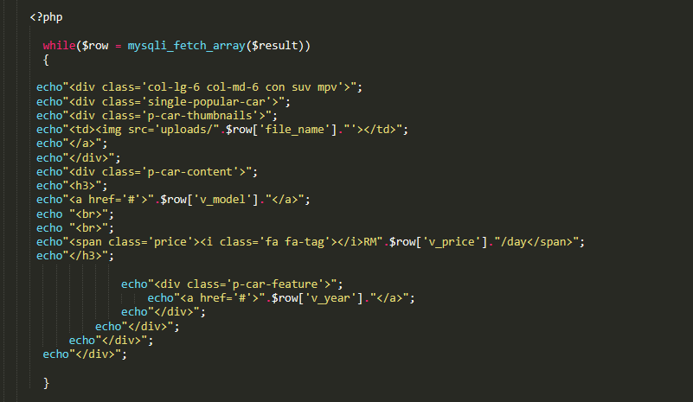

Extraction of Information from Database in Booking Page

5. Avoid Backdated Booking

- The minimum date is set to the current date to prevent the user from choosing past dates.

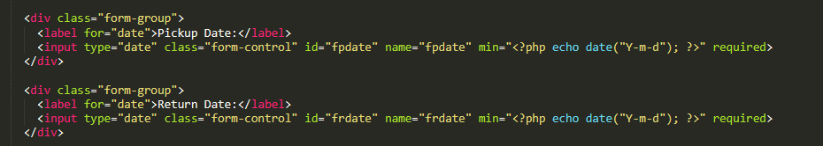

Backdating Prevention Coding

6. Confirmation, Notification and Verification

- Confirmation, notification and verification functions were applied mostly in administrator side.

- Admin can confirm bookings, receive notification about recent bookings.

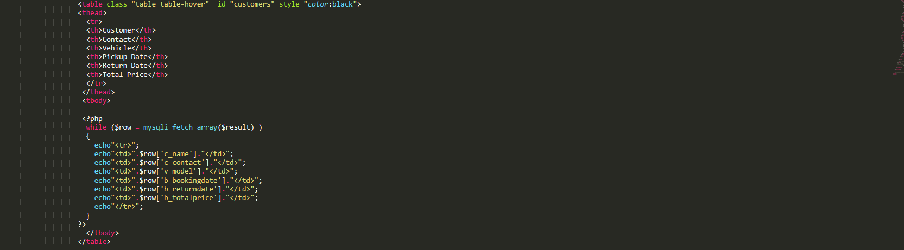

Recent Bookings Coding

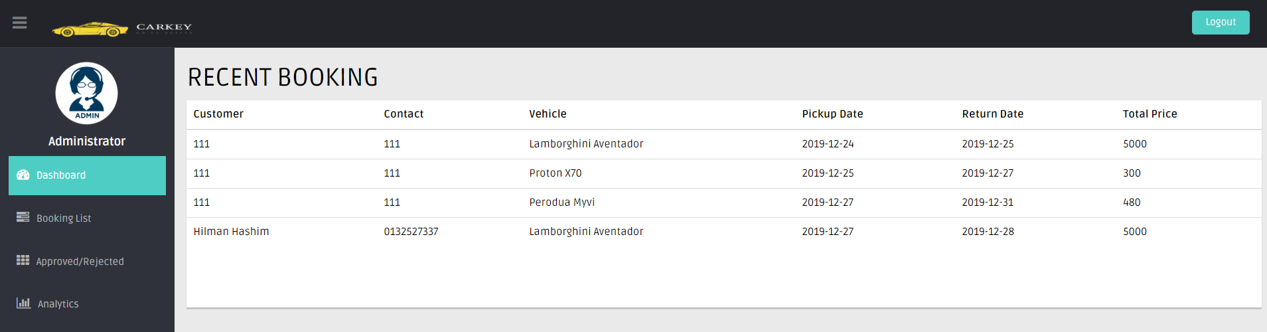

Admin’s Recent Booking Notification

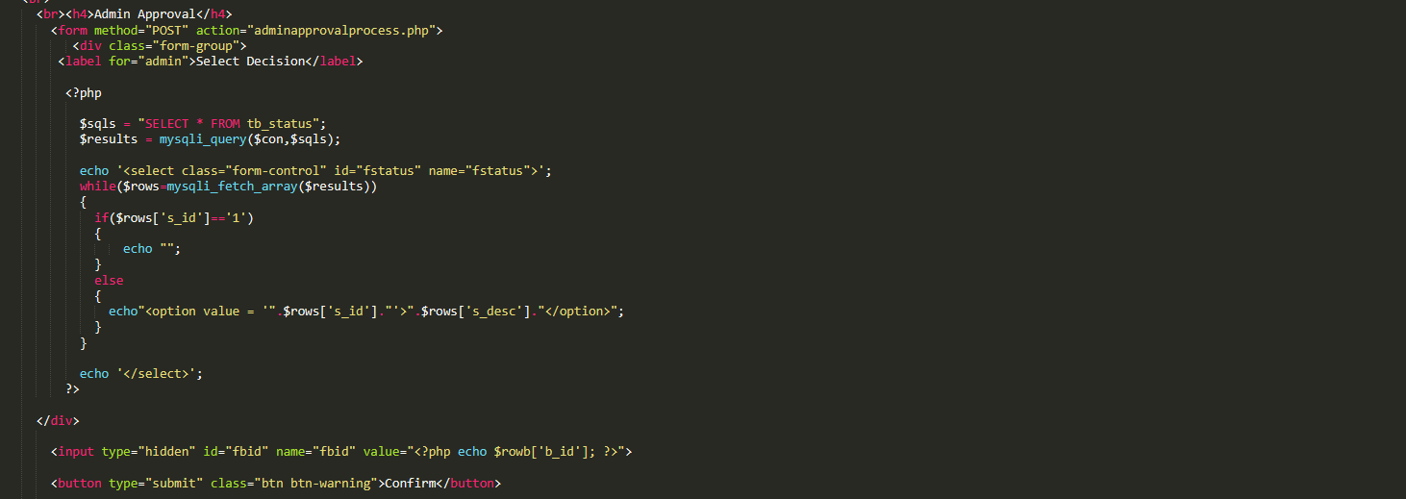

Admin’s Confirmation Coding

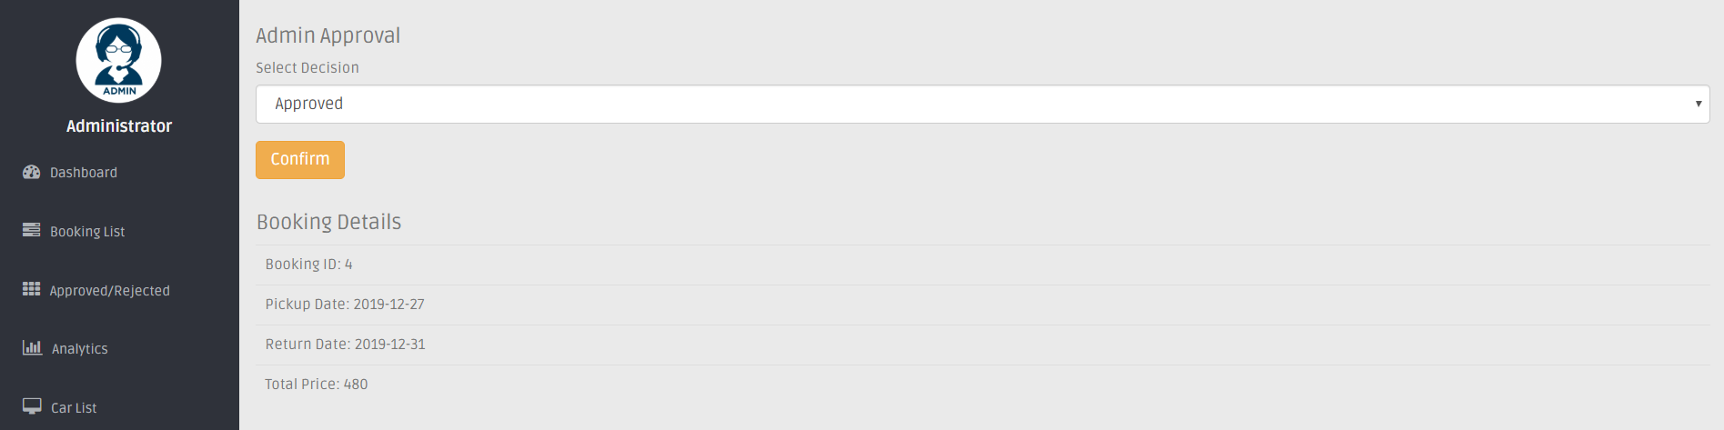

Admin’s Confirmation Page

7. Data Analytics

- Admin can look at the statistics of type of cars booked in order to make decision whether the responding car is a good investment or not to be keep in the company.

- The chart used is pie chart.

- Google Chart was used in order to complete this task.

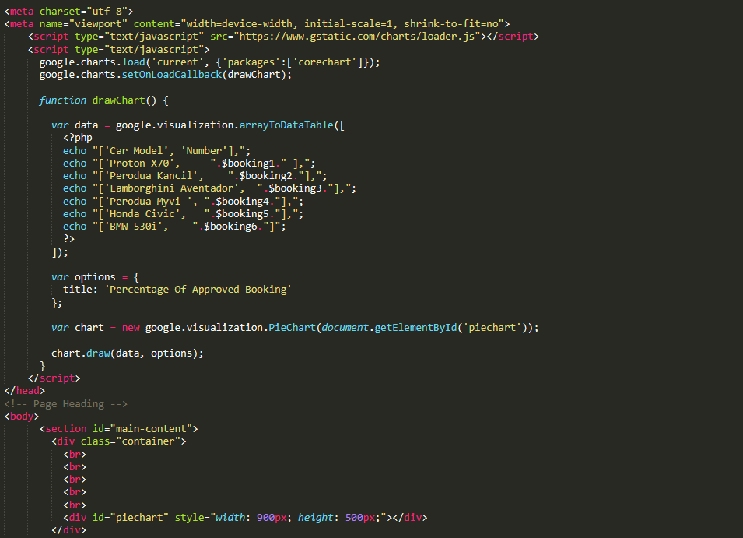

Data Analytics Coding

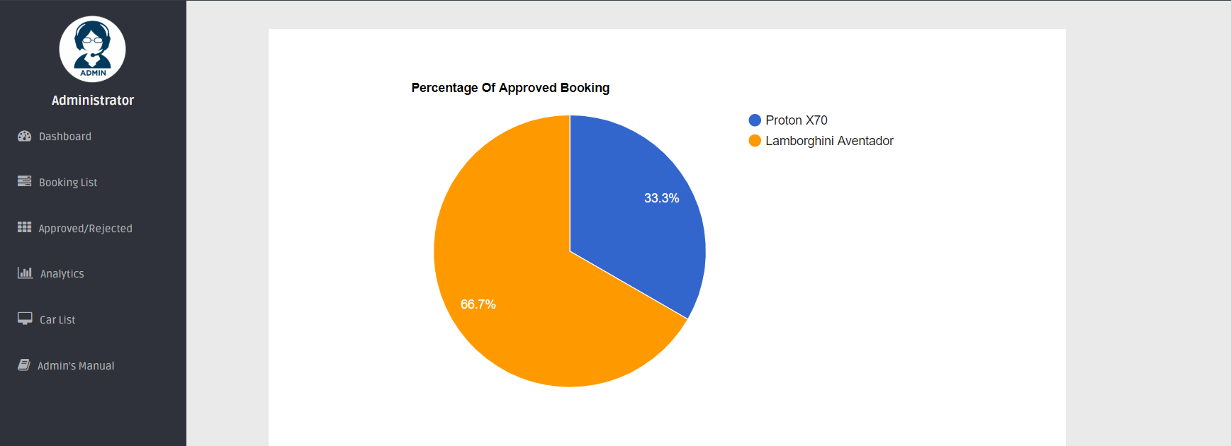

Data Analytics Page

8. Login Conflict Between Admin & Customer.

- Session was placed in all pages in order to prevent customer from having access to admin’s page and vice versa.

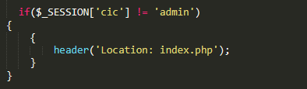

Session for Admin’s Side Coding

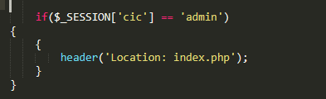

Session for User’s Side Coding

9. Pagination

- Pagination was used in almost all tables that was shown in the website for better and easier navigation for both admin and user.

- Bootstrap and Javascript was used to create this pagination on every table.

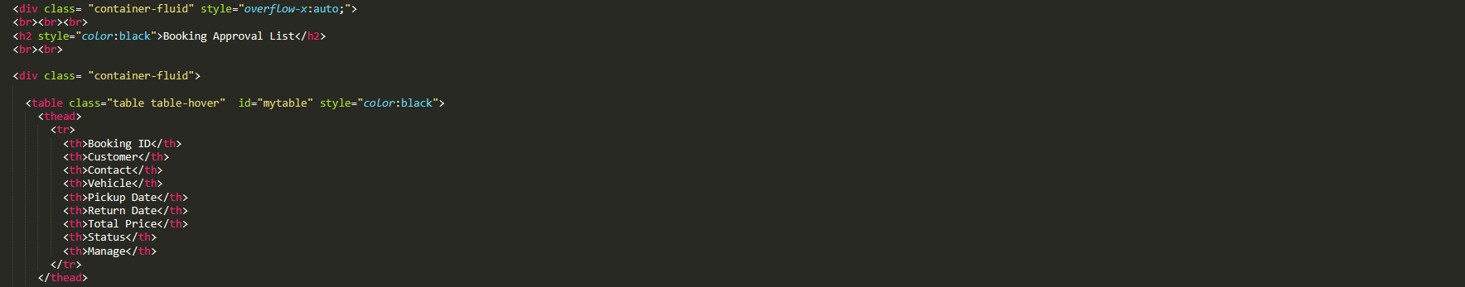

Pagination Coding

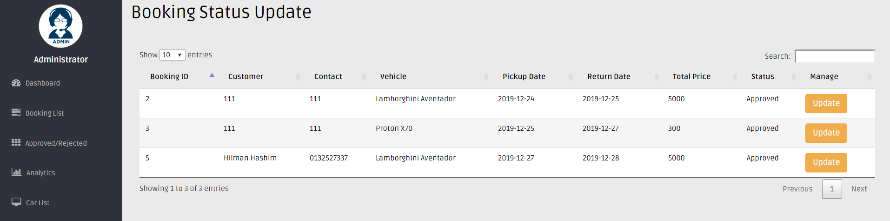

Pagination Example

Live Hosting URL & Credentials

URL: https://carkeyhilman.000webhostapp.com/

Credentials:

**Administrator**

Login ID – admin

Password – admin

**User**

Login ID – 123

Password - 123